'Issue report

Test Case #1

Test Case Steps:

1. Open browser and go to: <http://demo.baasic.com/angular/starterkit-photo-gallery/main>

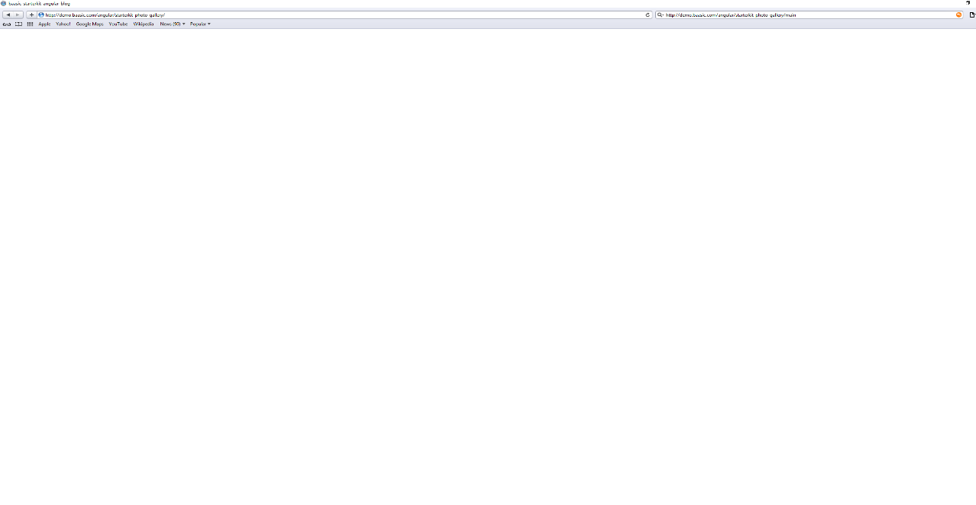Screenshot:

Test Case #2

Test Case Steps:

1. Open browser and go to: <http://demo.baasic.com/angular/starterkit-photo-gallery/main>
2. Picture should be visible in the left upper corner of webpage

-Picture is not visible in Internet Explorer browser.

Screenshot:

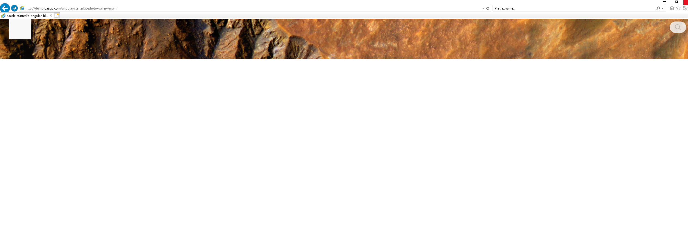

Test Case #3

Test Case Steps:

1. Open browser and go to: <http://demo.baasic.com/angular/starterkit-photo-gallery/main>
2. Click on ‘Search bar’
3. Type name of the picture

- In Internet Explorer, ‘Search bar’ looks like it doesn’t work because it is not highlighted, and by clicking on ‘search’ it doesn’t say ‘Search…’ inside of the box.

Screenshot:

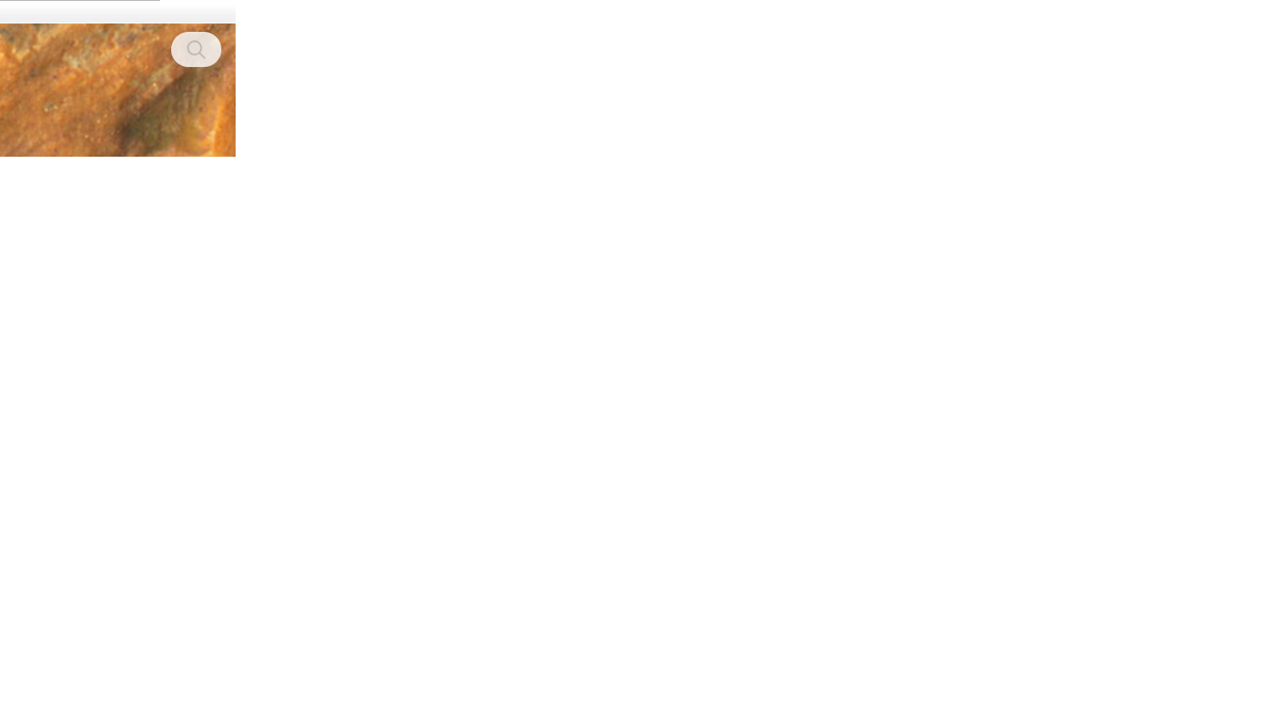

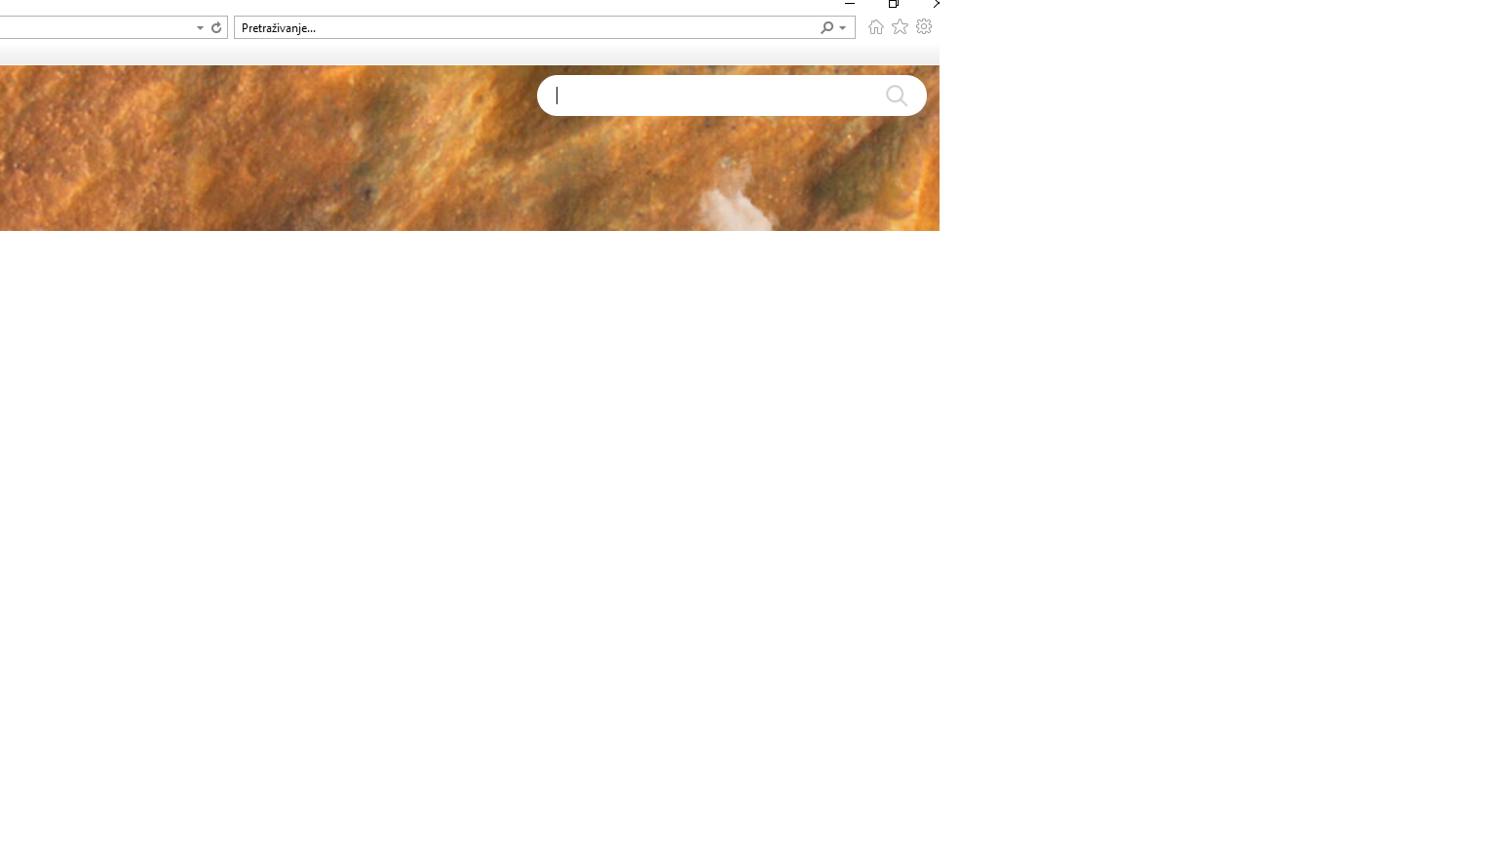

Test Case #3.1

Test Case Steps:

1. Open browser and go to: <http://demo.baasic.com/angular/starterkit-photo-gallery/main>
2. Click on ‘Search bar’
3. Type e.g. letter ‘a’

- Before any results, webpage throws message that there are no photos with the letter ‘a’

Screenshot:

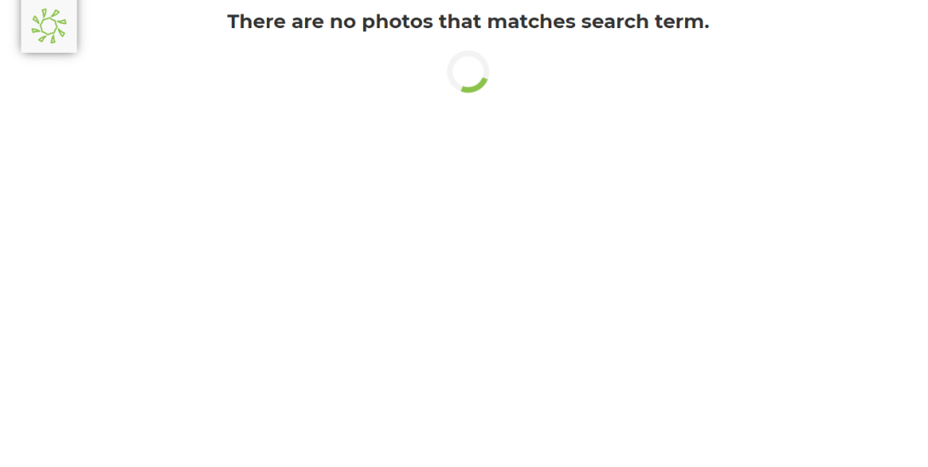

Test Case #3.2

Test Case Steps:

1. Open browser and go to: <http://demo.baasic.com/angular/starterkit-photo-gallery/main>
2. Click on ‘Search bar’
3. Type e.g. letter ‘a’
4. Scroll down to see the results

- After all the photos have been displayed, the spinner is still in function.

Screenshot:



Test Case #4

Test Case Steps:

1. Open browser and go to: <http://demo.baasic.com/angular/starterkit-photo-gallery/main>
2. Lean the mouse on ‘Menu’

- Picture is not shown in Internet Explorer.

Screenshot:

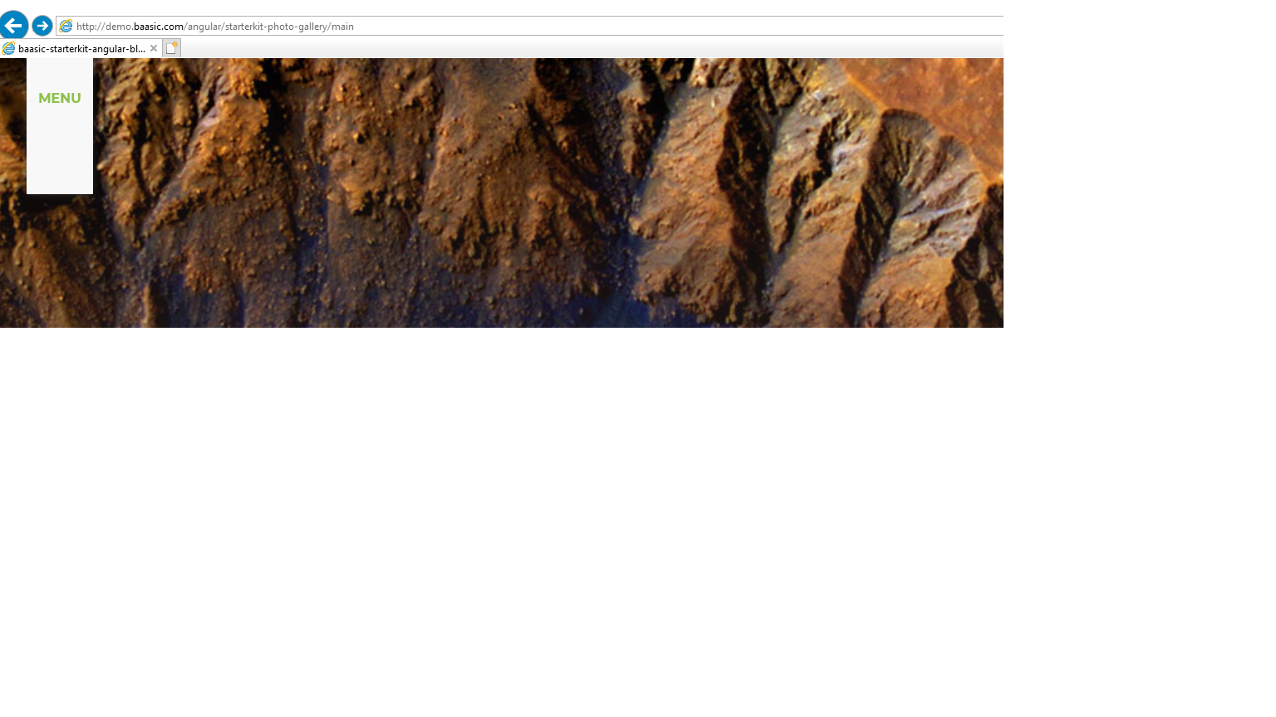

Test Case #6

Test Case Steps:

1. Open browser and go to: <http://demo.baasic.com/angular/starterkit-photo-gallery/main>
2. Click on button that shows pictures on main page
3. Scroll down to see if pictures appear
4. Click again on the button to see if pictures are hidden

-Button is not visible only in Internet Explorer browser and it doesn’t show any pictures.

Screenshot:

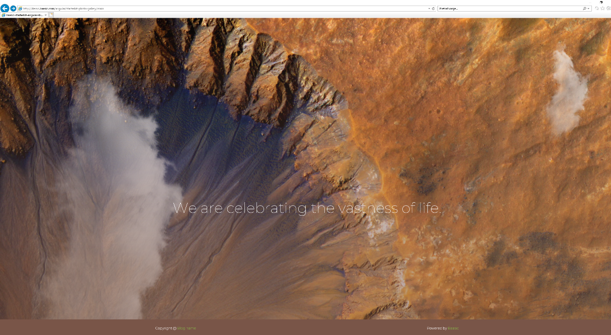

Test Case #7

Test Case Steps:

1. Open browser and go to: <http://demo.baasic.com/angular/starterkit-photo-gallery/main>
2. Scroll down to footer of webpage
3. Click on link: ‘Blog name’.

- By clicking on link, none of used browsers (Google Chrome, Mozilla Firefox, Opera and Internet Explorer) didn’t open link.

Screenshot:

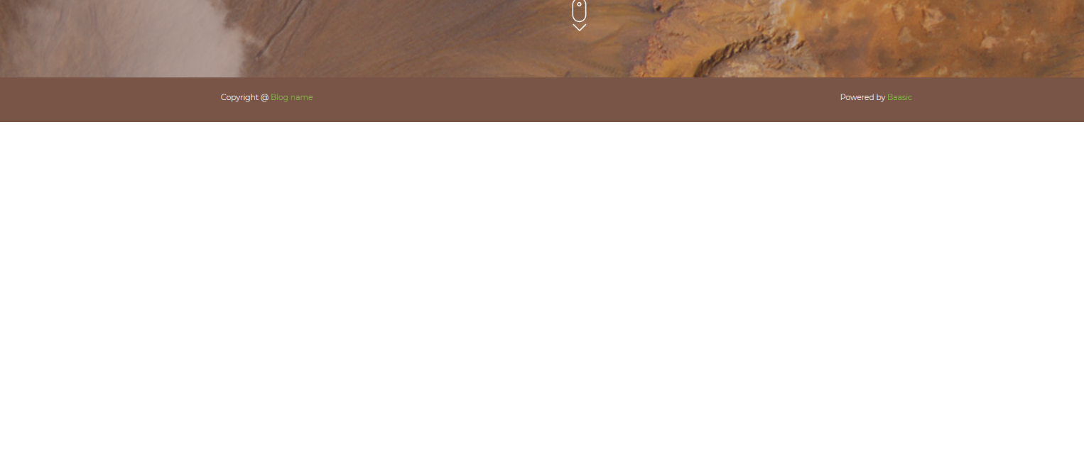

Test Case #9

Test Case Steps:

1. Open browser and go to: <http://demo.baasic.com/angular/starterkit-photo-gallery/main>
2. Click on the button that shows pictures on main page
3. Scroll down to see if pictures have shown
4. Click F12
5. Open developer tools - Network
6. Click CTRL+ R to get the list of all pictures
7. Look what the speed of request is

- Speed of request in general is more than 500 ms, approximately 6 s.

Screenshot:

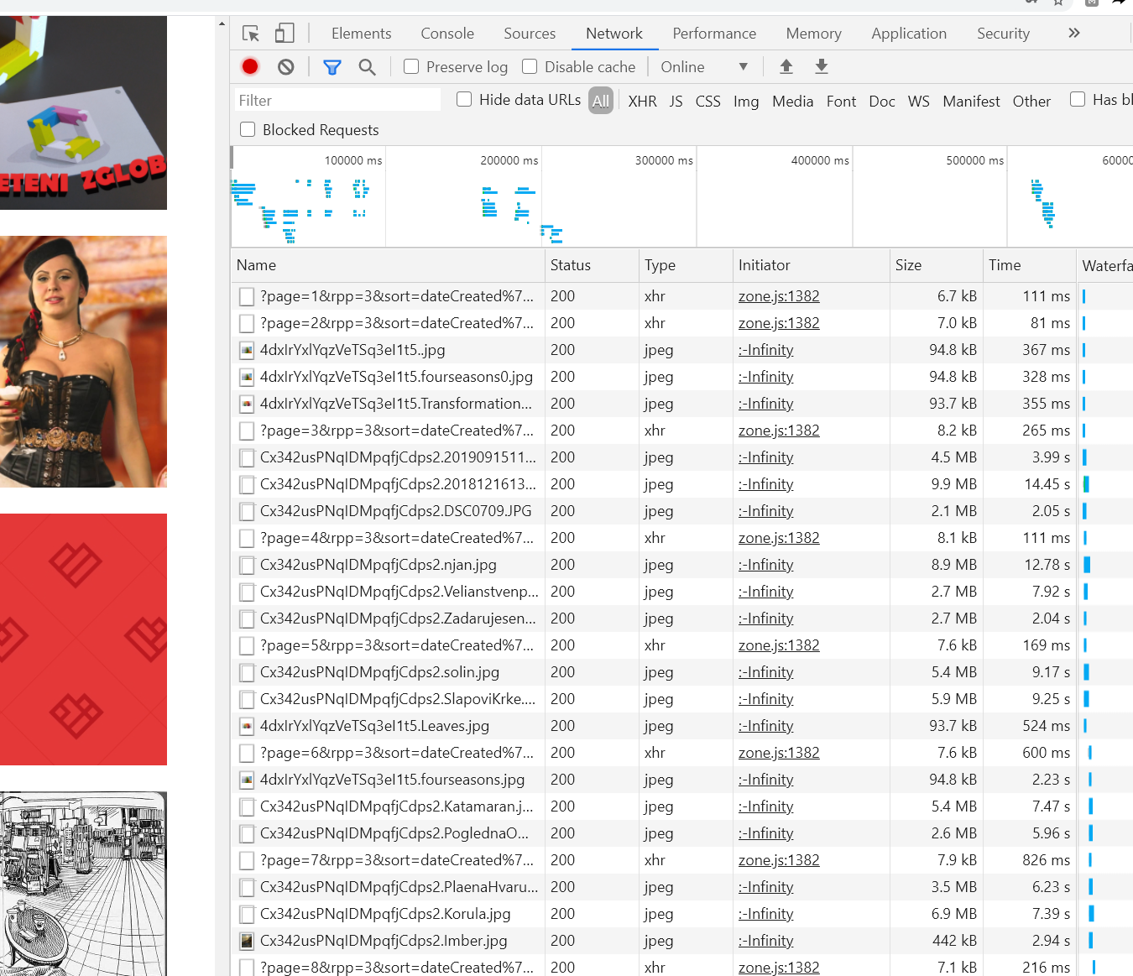

Test Case #10

Test Case Steps:

1. Open browser and go to: <http://demo.baasic.com/angular/starterkit-photo-gallery/main>
2. Click on the button that shows pictures on main page
3. Click on the picture to open it

- Pictures are not opening in Internet Explorer and on mobile version.

Screenshot

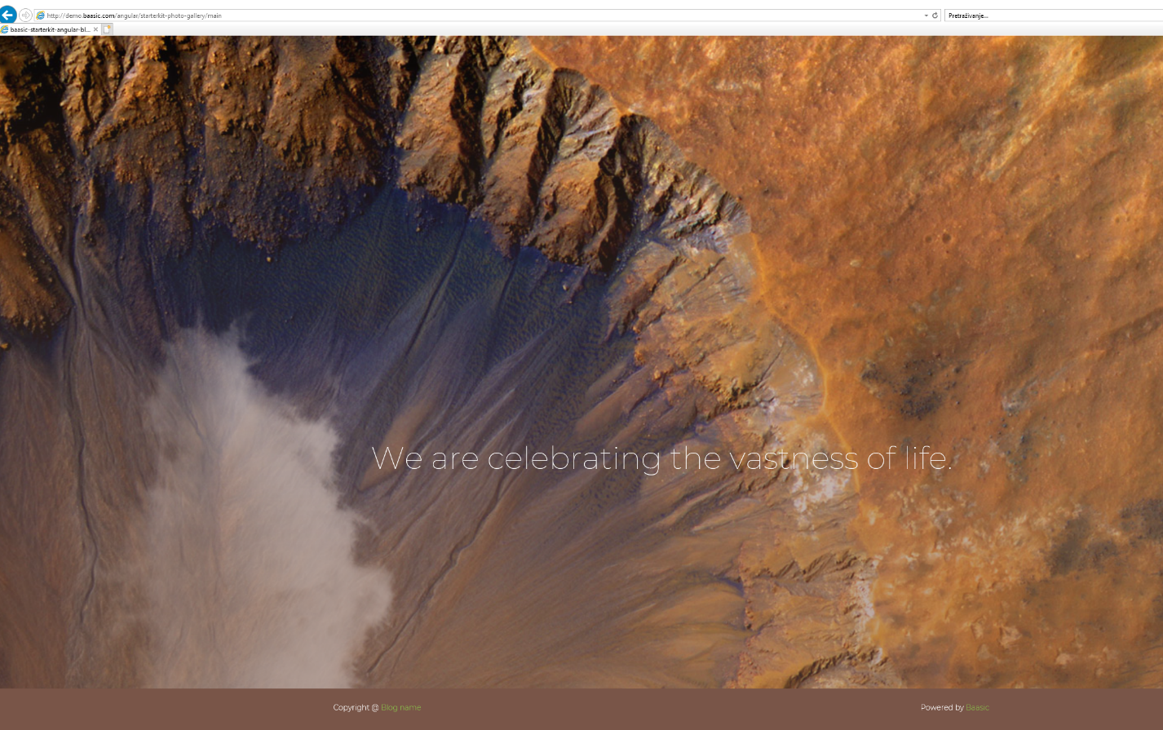

Test Case #12

Test Case Steps:

1. Open browser and go to: <http://demo.baasic.com/angular/starterkit-photo-gallery/main>
2. Click on the button that shows photos on main page
3. Click on any photo
4. Click on ’back’ or ‘X’ button
5. Scroll down through Main page

- While scrolling down on the main page, the edge of the initial photos appear briefly and by scrolling up, photos remove.

Screenshot

Scrolling down

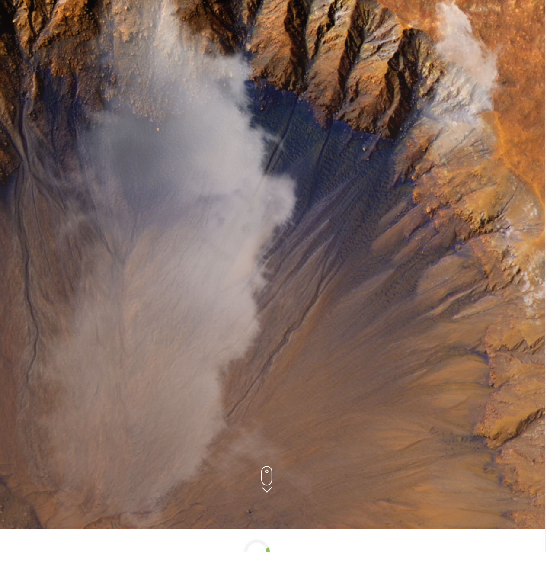

Screenshot

Scrolling up:

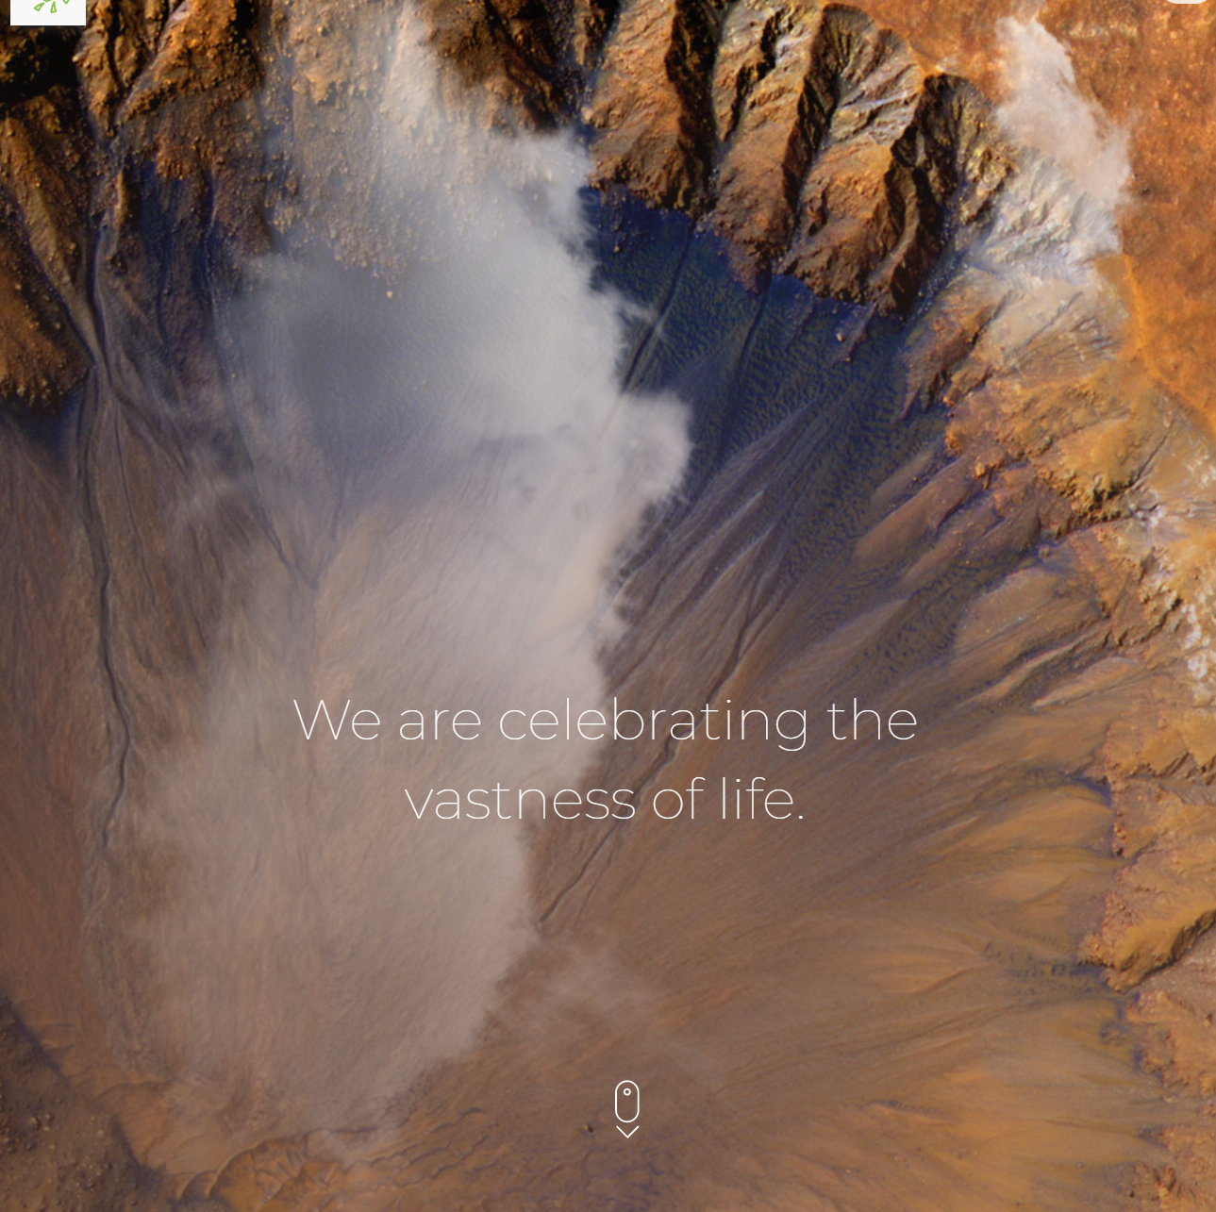

Test Case #13

Test Case Steps:

1. Open browser and go to: <http://demo.baasic.com/angular/starterkit-photo-gallery/main>
2. Scroll down

- After scrolling down, background photo is bigger than before scrolling down the page only on mobile version.

Screenshot:

Before scrolling down:

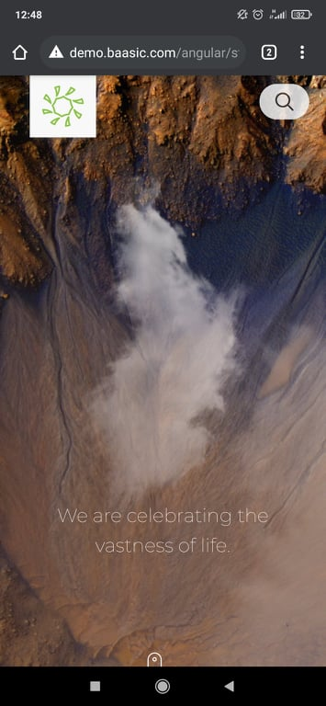

Screenshot:

After scrolling down:

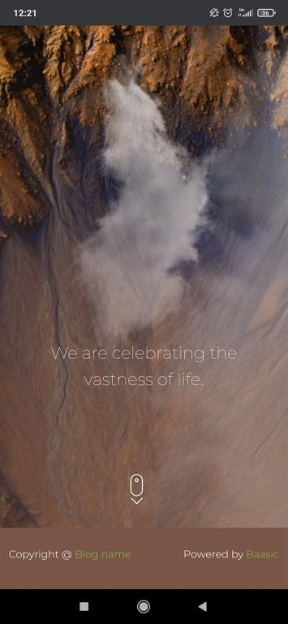

Test Case #17.1

Test Case Steps:

1. Open browser and go to: <http://demo.baasic.com/angular/starterkit-photo-gallery/main>
2. Lean the mouse on picture (logo)
3. Click on ‘Menu’
4. Click on ‘Register’
5. Type correct email address
6. Type incorrect username, e.g.: ….
7. Type correct password
8. Confirm password
9. Click the button ‘Register’

- By typing into username with dots is correct and it doesn’t get any errors in any browser used.

Screenshot:

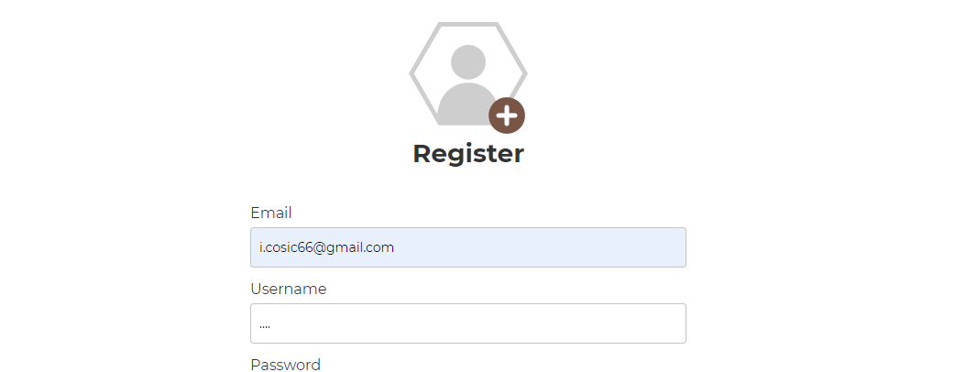

Test Case #17.2

Test Case Steps:

1. Open browser and go to: <http://demo.baasic.com/angular/starterkit-photo-gallery/main>
2. Lean the mouse on picture (logo)
3. Click on ‘Menu’
4. Click on ‘Register’
5. Type correct email address
6. Type incorrect username, e.g. typing space inside the username field
7. Type correct password
8. Confirm password
9. Click the button ‘Register’

-By typing into username with spaces is correct and it doesn’t get any errors in any browser used.

Screenshot:

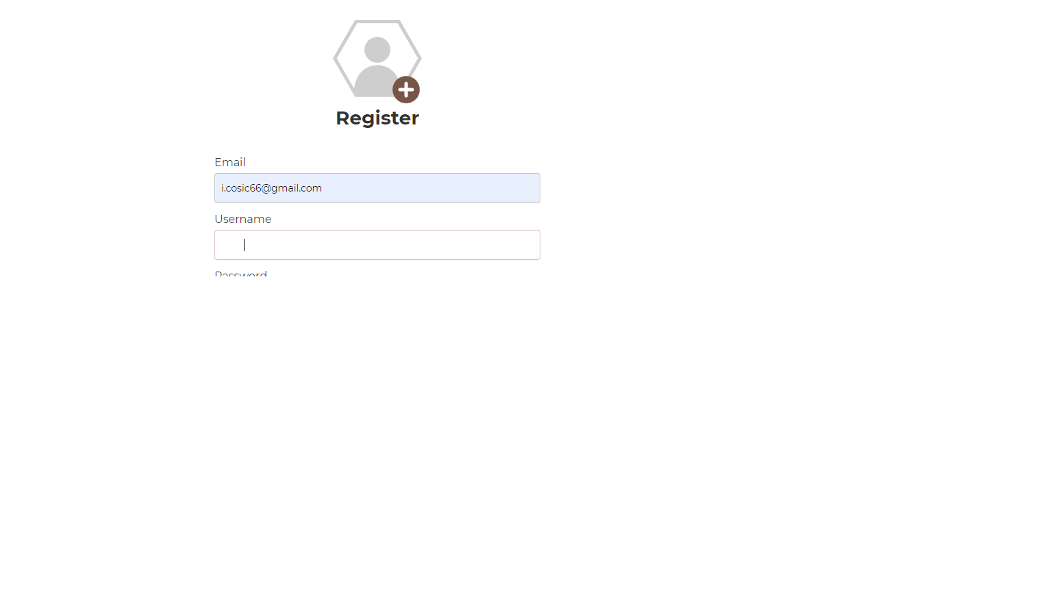

Test Case #17.3

Test Case Steps:

1. Open browser and go to: <http://demo.baasic.com/angular/starterkit-photo-gallery/main>
2. Lean the mouse on picture (logo)
3. Click on ‘Menu’
4. Click on ‘Register’
5. Type correct email address
6. Type incorrect username, e.g. typing punctuation marks inside the username field
7. Type correct password
8. Confirm password
9. Click the button ‘Register’

- By typing into username with punctuation marks is correct and it doesn’t get any errors in any browser used.

Screenshot:

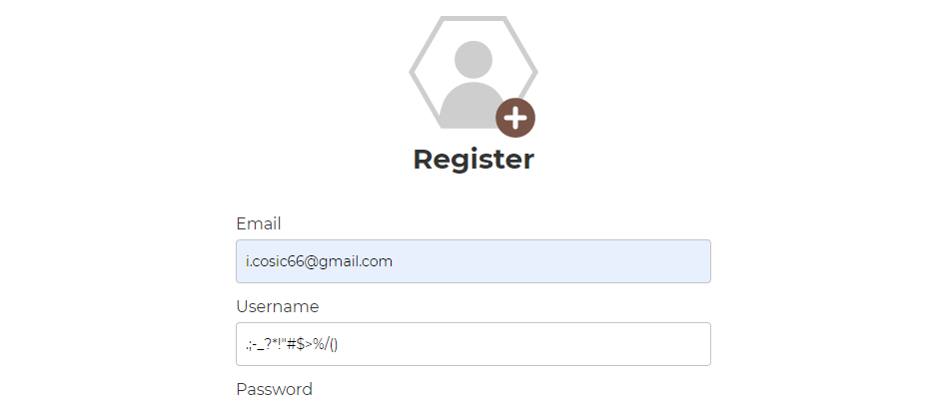

Test Case #18

Test Case Steps:

1. Open browser and go to: <http://demo.baasic.com/angular/starterkit-photo-gallery/main>
2. Lean the mouse on picture (logo)
3. Click on ‘Menu’
4. Click on ‘Register’
5. Type correct email address
6. Type username that’s taken
7. Type too short password (less than 6 characters)
8. Confirm password
9. Click the button ‘Register’

- By typing too short password and username that’s taken, user only gets message for too short password in Opera and Internet Explorer browser.

Screenshot:

Opera:

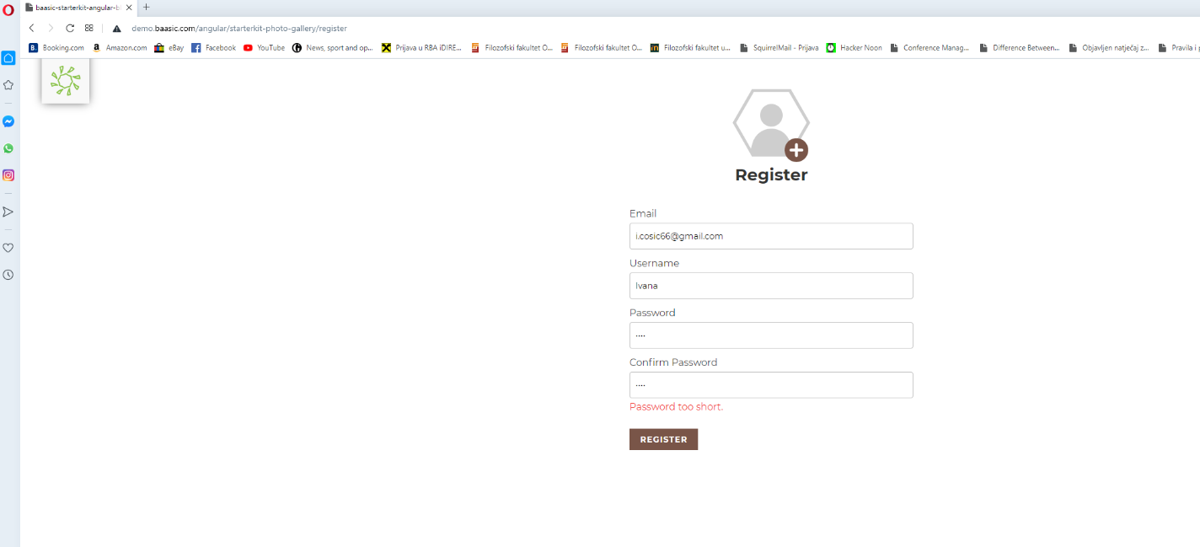

Internet Explorer:

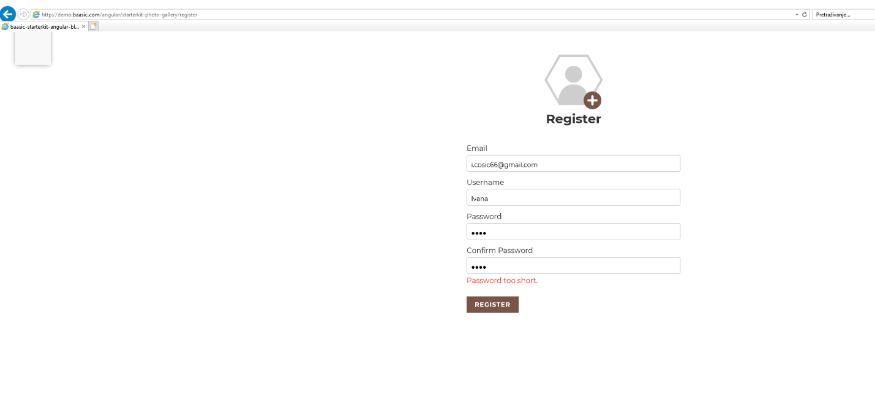

Example in Mozilla Firefox:

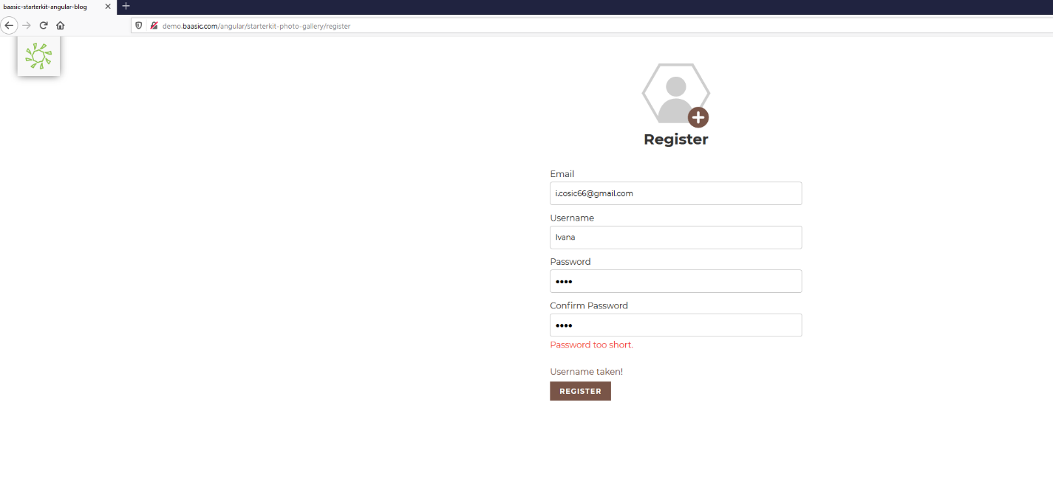

Test Case #18.1

Test Case Steps:

1. Open browser and go to: <http://demo.baasic.com/angular/starterkit-photo-gallery/main>
2. Lean the mouse on picture (logo)
3. Click on ‘Menu’
4. Click on ‘Register’
5. Type correct email address
6. Type correct username
7. Type password that only contains spaces
8. Confirm the same password
9. Click the button ‘Register’

-By typing password that contains spaces, user is not getting any error.

Screenshot:

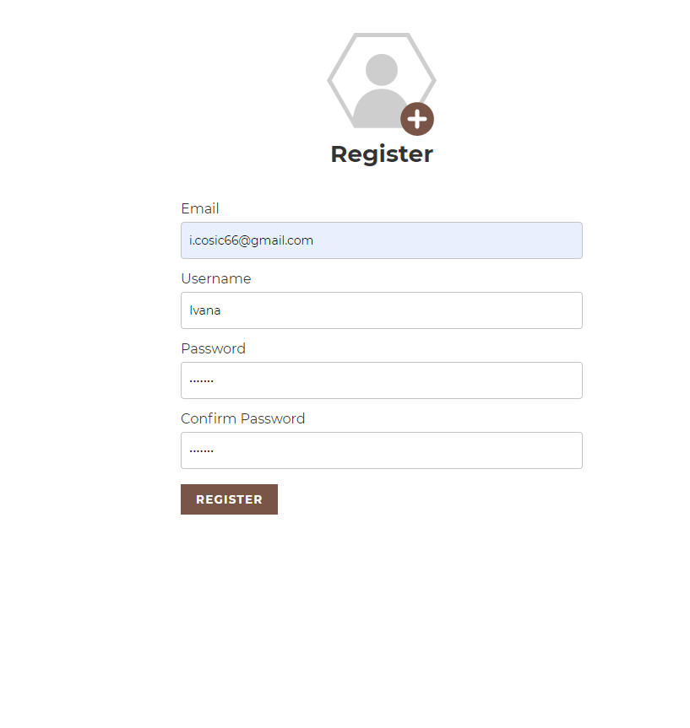

Test Case #19

Test Case Steps:

1. Open browser and go to: <http://demo.baasic.com/angular/starterkit-photo-gallery/main>
2. Lean the mouse on picture (logo)
3. Click on ‘Menu’
4. Click on ‘Register’
5. Type correct email address
6. Type correct username
7. Type correct password
8. Confirm the same password
9. Click the button ‘Register’
10. Pop-up for remembering password

Screenshot without the message: (Google Chrome)



Screenshot with the message: (Mozilla Firefox)

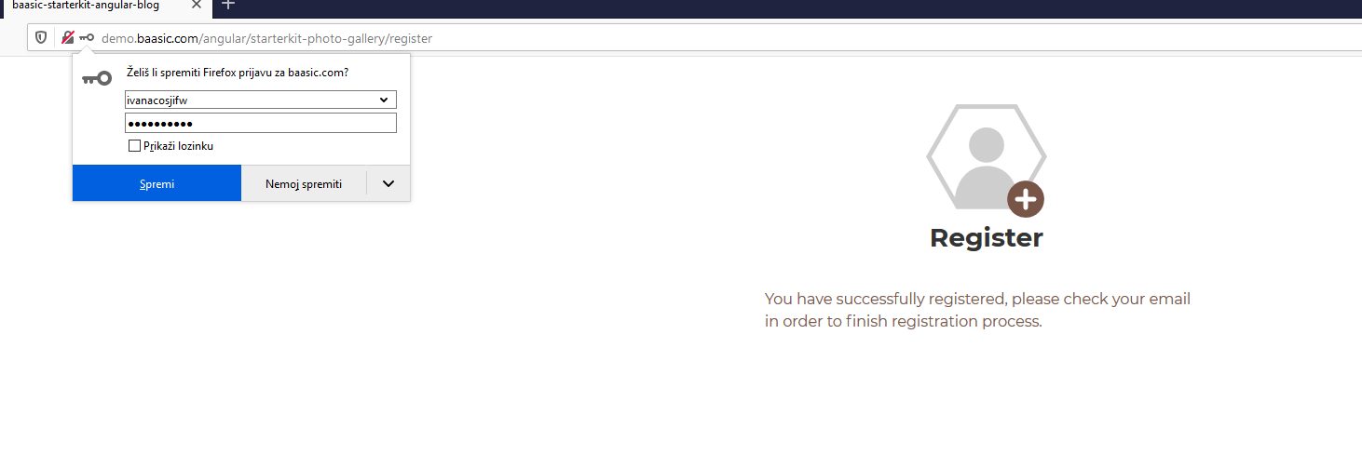

Test Case #23.1

Test Case Steps:

1. Open browser and go to: <http://demo.baasic.com/angular/starterkit-photo-gallery/main>
2. Lean the mouse on picture (logo)
3. Click on ‘Menu’
4. Click on ‘Login’
5. Click on link: ‘Forgot your password? Recover your password here!’
6. Type correct email address
7. Click the button ‘Recover password’
8. Go to email
9. Click the button ‘Set new password’

- The button ‘Set new password’ on email gives an error, and password cannot be recovered.

Screenshot:

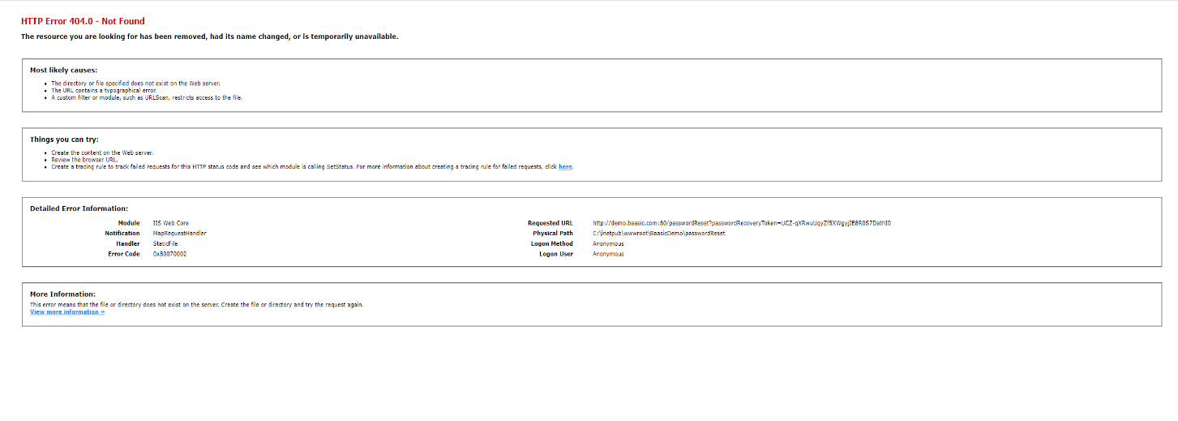

Test Case #24

Test Case Steps:

1. Open browser and go to: <http://demo.baasic.com/angular/starterkit-photo-gallery/main>
2. Lean the mouse on picture (logo)
3. Click on ‘Menu’
4. Click on ‘Login’
5. Click the buttons ‘Facebook’, ‘Twitter’, ‘Google’ and ‘Github’

- The buttons don’t work and they give an error: ‘Undefined: Social login configuration not found.’

Screenshot:

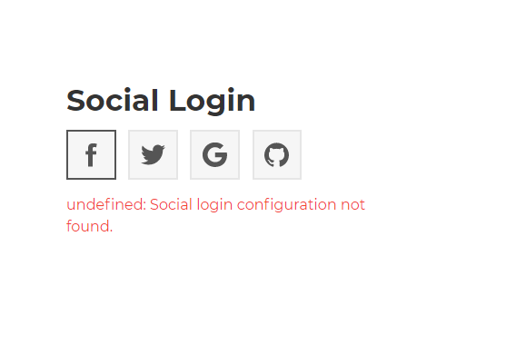

Test Case #25

Test Case Steps:

1. Open browser and go to: <http://demo.baasic.com/angular/starterkit-photo-gallery/main>
2. Lean the mouse on picture (logo)
3. Click on ‘Menu’
4. Click on ‘Login’

- The ‘Menu’ icon is over the text Login so text is not fully readable so display information is not good on mobile browser.

Screenshot:

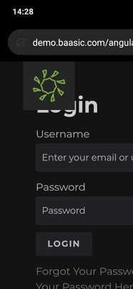

Test Case #29

Test Case Steps:

1. Open browser and go to: <http://demo.baasic.com/angular/starterkit-photo-gallery/main>
2. Lean the mouse on photo (logo)
3. Click on ‘Menu’
4. Click on ‘Login’
5. Type correct username or email address
6. Type correct password
7. Click button ‘Login’ - ‘Photo Gallery’ page/profile
8. Lean the mouse on photo (logo)
9. Click on ‘Menu’
10. Lean the mouse on photo (logo)

-‘Menu’ icon looks like it doesn’t work, nothing happens when the mouse is on the photo (logo)

Screenshot:

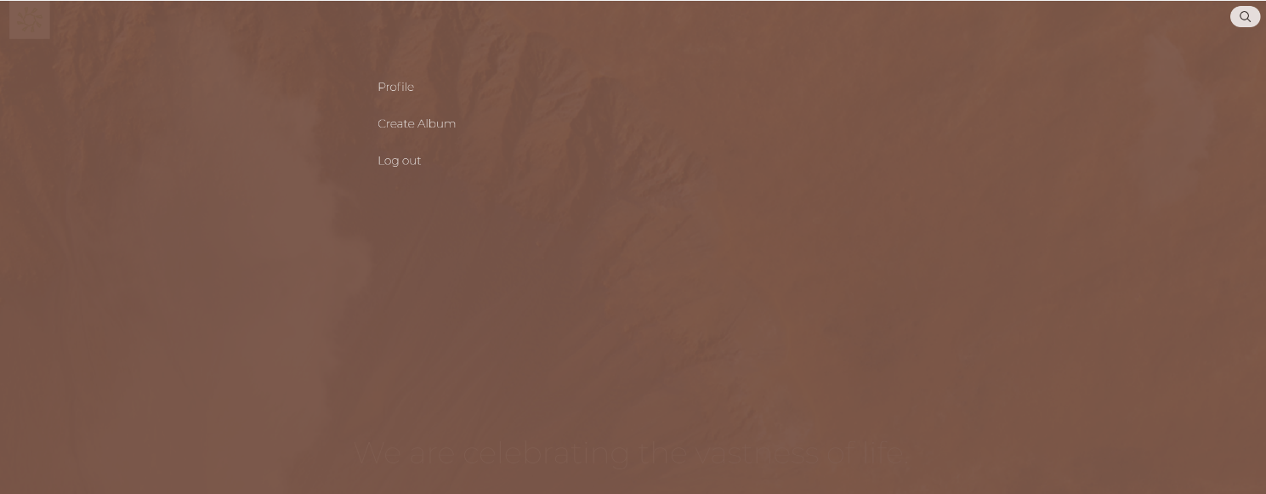

Test Case #30

Test Case Steps:

1. Open browser and go to: <http://demo.baasic.com/angular/starterkit-photo-gallery/main>
2. Lean the mouse on photo (logo)
3. Click on ‘Menu’
4. Click on ‘Login’
5. Type correct username or email address
6. Type correct password
7. Click button ‘Login’ - ‘Photo Gallery’ page/profile
8. Lean the mouse on photo (logo)
9. Click on ‘Menu’
10. Click on the ‘X’ button

-‘X’ button is not visible, so user can click anywhere on the page to close the menu.

Screenshot:

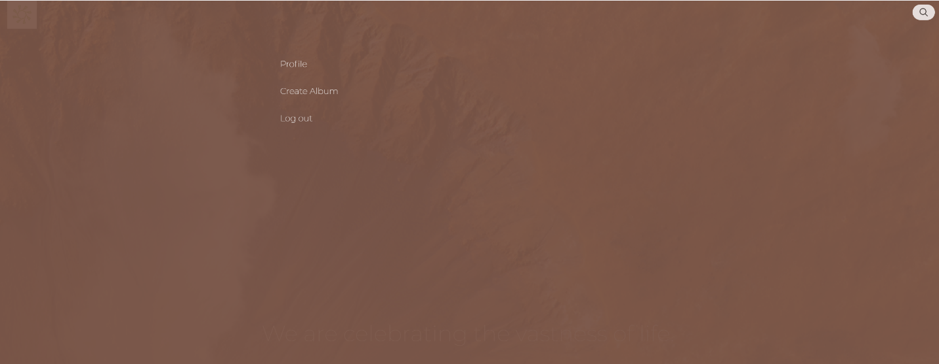

Test Case #35.1

Test Case Steps:

1. Open browser and go to: <http://demo.baasic.com/angular/starterkit-photo-gallery/main>
2. Lean the mouse on photo (logo)
3. Click on ‘Menu’
4. Click on ‘Login’
5. Type correct username or email address
6. Type correct password
7. Click button ‘Login’ - ‘Photo Gallery’ page/profile
8. Lean the mouse on photo (logo)
9. Click on ‘Menu’
10. Click on ’Profile’
11. Lean the mouse on album cover photo
12. Click on ‘Delete’

- With ‘Delete’ button user can delete album and with ‘Cancel’ button he can leave and not delete album. On mobile version ‘delete’ option doesn’t exists.

Screenshot:

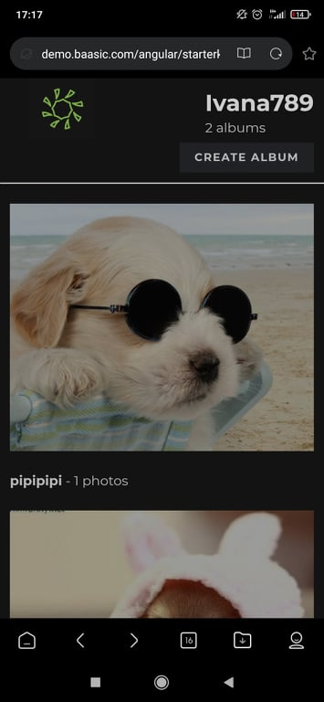

Test Case #35.2

Test Case Steps:

1. Open browser and go to: <http://demo.baasic.com/angular/starterkit-photo-gallery/main>
2. Lean the mouse on photo (logo)
3. Click on ‘Menu’
4. Click on ‘Login’
5. Type correct username or email address
6. Type correct password
7. Click button ‘Login’ - ‘Photo Gallery’ page/profile
8. Lean the mouse on photo (logo)
9. Click on ‘Menu’
10. Click on ’Profile’
11. Lean the mouse on album cover photo
12. Click on ‘Delete’
13. Pop-up - click on ‘Cancel’ or ‘Delete’

- With ‘Delete’ button user can delete album and with ‘Cancel’ button he can leave and not delete album. On mobile version ‘delete’ option doesn’t exists.

Screenshot:



Test Case #36

Test Case Steps:

1. Open browser and go to: <http://demo.baasic.com/angular/starterkit-photo-gallery/main>
2. Lean the mouse on photo (logo)
3. Click on ‘Menu’
4. Click on ‘Login’
5. Type correct username or email address
6. Type correct password
7. Click button ‘Login’ - ‘Photo Gallery’ page/profile
8. Lean the mouse on photo (logo)
9. Click on ‘Menu’
10. Click on ’Profile’
11. Lean the mouse on album cover photo
12. Click on album cover photo
13. Lean the mouse on photo
14. Click on ‘Delete’

- With ‘Delete’ button user can delete photo. On mobile version delete option doesn’t’ exists.

Screenshot:

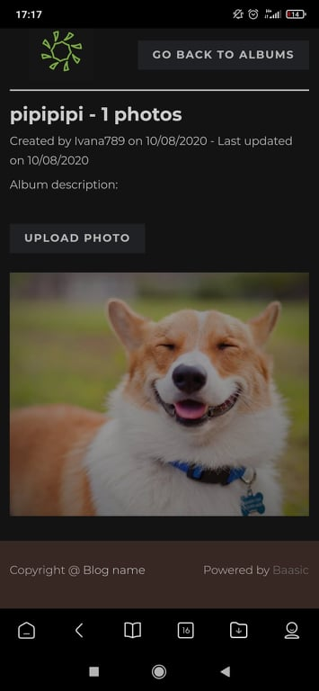

Test Case #36.1

Test Case Steps:

1. Open browser and go to: <http://demo.baasic.com/angular/starterkit-photo-gallery/main>
2. Lean the mouse on photo (logo)
3. Click on ‘Menu’
4. Click on ‘Login’
5. Type correct username or email address
6. Type correct password
7. Click button ‘Login’ - ‘Photo Gallery’ page/profile
8. Lean the mouse on photo (logo)
9. Click on ‘Menu’
10. Click on ’Profile’
11. Lean the mouse on album cover photo
12. Click on album cover photo
13. Lean the mouse on photo
14. Click on ‘Delete’
15. Pop-up - click on ‘Cancel’ or ‘Delete’

- With ‘Delete’ button user can delete photo and with ‘Cancel’ button he can leave and not delete photo. On mobile version delete option doesn’t exists.

Screenshot:



Test Case #36.2

Test Case Steps:

1. Open browser and go to: <http://demo.baasic.com/angular/starterkit-photo-gallery/main>
2. Lean the mouse on photo (logo)
3. Click on ‘Menu’
4. Click on ‘Login’
5. Type correct username or email address
6. Type correct password
7. Click button ‘Login’ - ‘Photo Gallery’ page/profile
8. Lean the mouse on photo (logo)
9. Click on ‘Menu’
10. Click on ’Profile’
11. Lean the mouse on album cover photo
12. Click on album cover photo
13. Lean the mouse on photo

- Photo doesn’t have option to update information e.g. description or title

Screenshot:

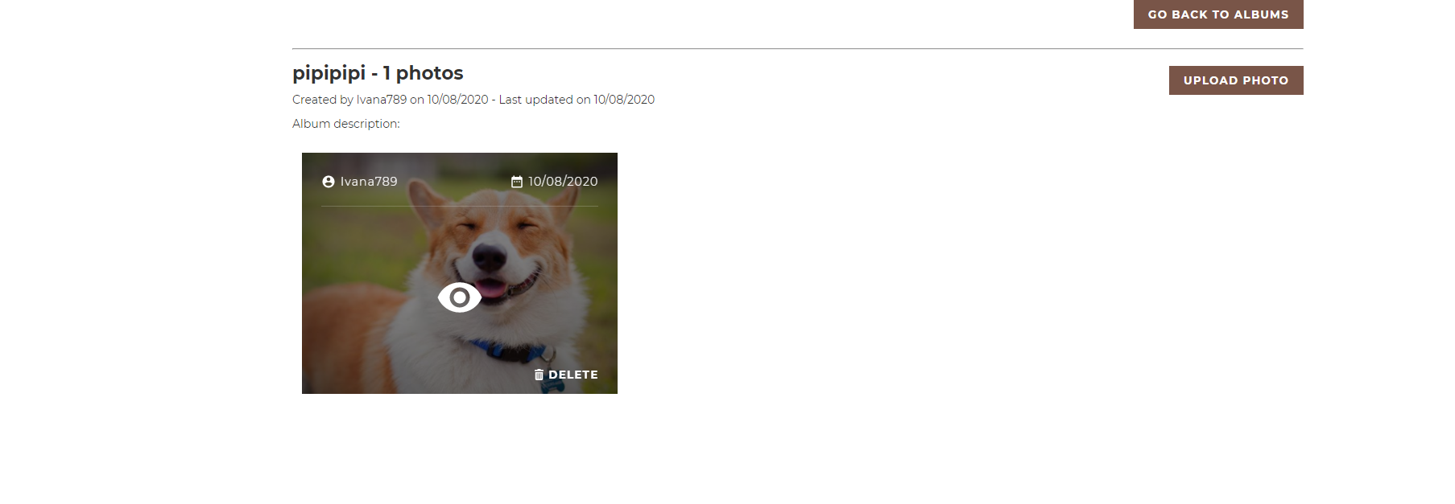

Test Case #36.3

Test Case Steps:

1. Open browser and go to: <http://demo.baasic.com/angular/starterkit-photo-gallery/main>
2. Lean the mouse on photo (logo)
3. Click on ‘Menu’
4. Click on ‘Login’
5. Type correct username or email address
6. Type correct password
7. Click button ‘Login’ - ‘Photo Gallery’ page/profile
8. Lean the mouse on photo (logo)
9. Click on ‘Menu’
10. Click on ’Profile’
11. Lean the mouse on album cover photo
12. Click on album cover photo
13. Lean the mouse on photo
14. Click on photo

- New page opened with error 404 with URL: [http://demo.baasic.com/angular/starterkit-photo-gallery/**](http://demo.baasic.com/angular/starterkit-photo-gallery/**)

Screenshot:

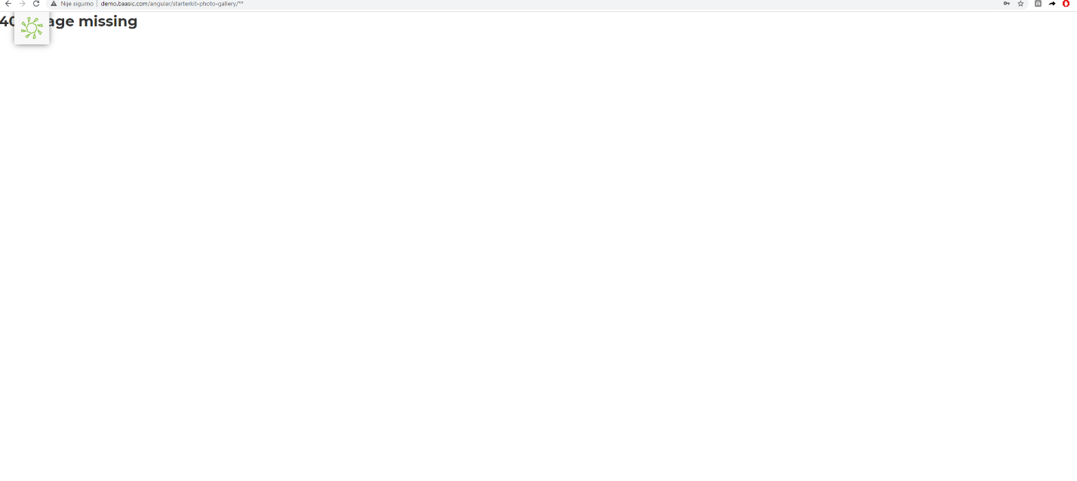

Test Case #38

Test Case Steps:

1. Open browser and go to: <http://demo.baasic.com/angular/starterkit-photo-gallery/main>
2. Lean the mouse on photo (logo)
3. Click on ‘Menu’
4. Click on ‘Login’
5. Type correct username or email address
6. Type correct password
7. Click button ‘Login’ - ‘Photo Gallery’ page/profile
8. Lean the mouse on photo (logo)
9. Click on ‘Menu’
10. Click on ’Profile’

- There are typos in text, e.g. 1 photos, 1 albums.

Screenshot:

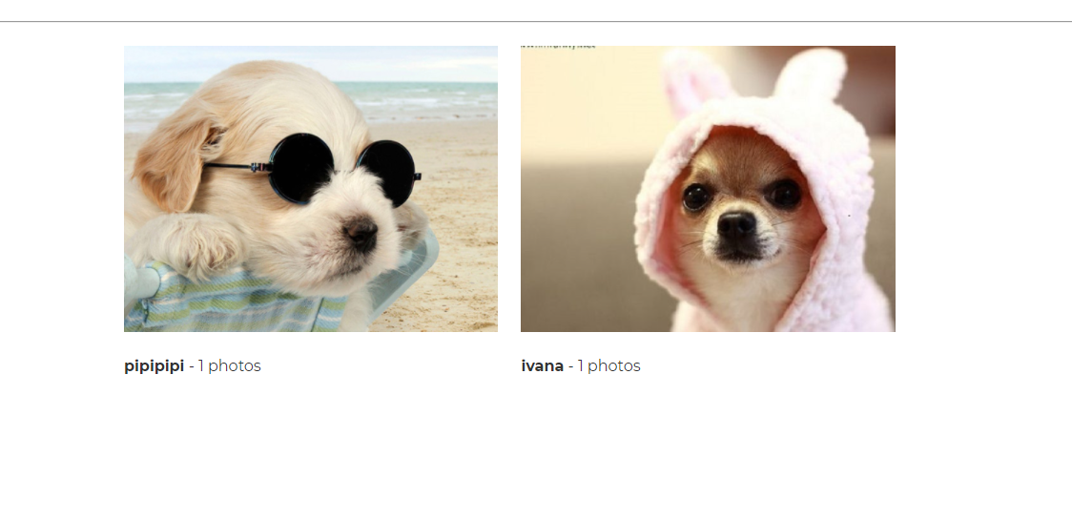

Test Case #39

Test Case Steps:

1. Open browser and go to: <http://demo.baasic.com/angular/starterkit-photo-gallery/main>
2. Lean the mouse on photo (logo)
3. Click on ‘Menu’
4. Click on ‘Login’
5. Type correct username or email address
6. Type correct password
7. Click button ‘Login’ - ‘Photo Gallery’ page/profile
8. Lean the mouse on photo (logo)
9. Click on ‘Menu’
10. Click on ’Profile’
11. Click on button ‘Create Album’
12. Fill fields ‘Album name’ and ‘Description
13. Click ‘Save album’
14. Upload photo
15. Click button ‘Upload’
16. Lean the mouse on photo (logo)
17. Click on ‘Menu’
18. Go to main page
19. Open cover album photo
20. Check date

- Photo that was created and updated today, has changed status with different date. E.g. (created and updated 10/08/2020), changed (10/09/2020).

Screenshot with correct date:

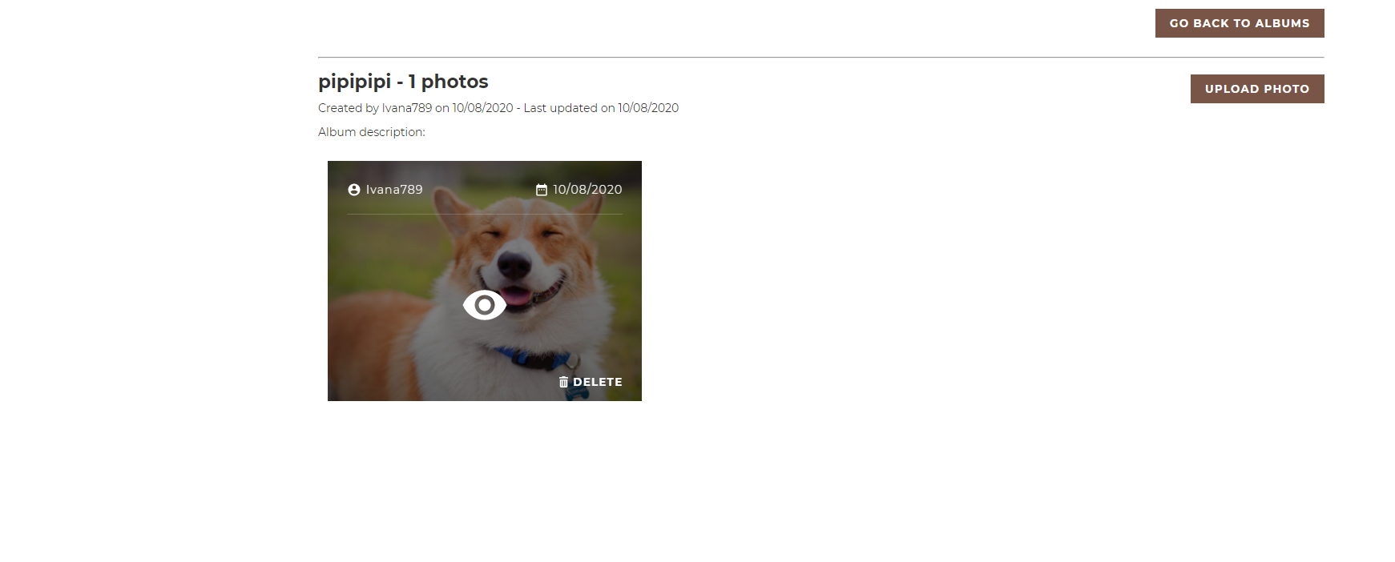

Screenshot with wrong date:

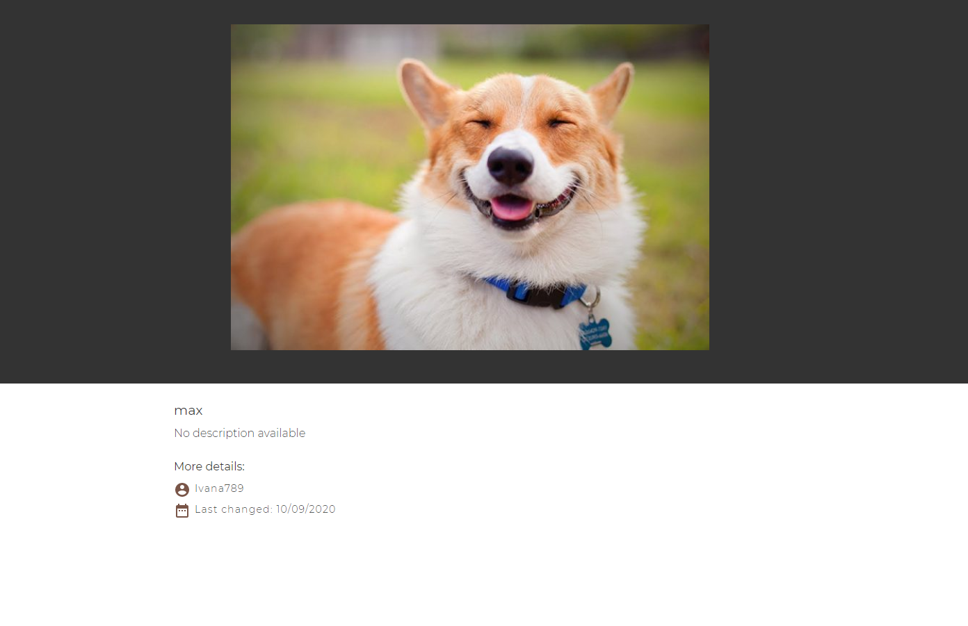

Test Case #41.1

Test Case Steps:

1. Open browser and go to: <http://demo.baasic.com/angular/starterkit-photo-gallery/main>
2. Lean the mouse on photo (logo)
3. Click on ‘Menu’
4. Click on ‘Login’
5. Type correct username or email address
6. Type correct password
7. Click button ‘Login’ - ‘Photo Gallery’ page/profile
8. Lean the mouse on photo (logo)
9. Click on ‘Menu’
10. Click on ‘Log out’

- There is no pop-up that says ‘Are you sure you want to log out?’

Screenshot:

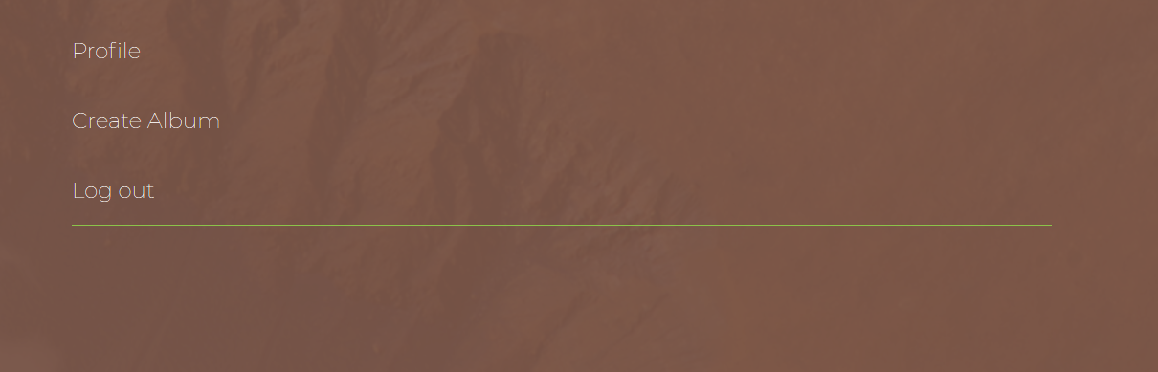

Screenshot:

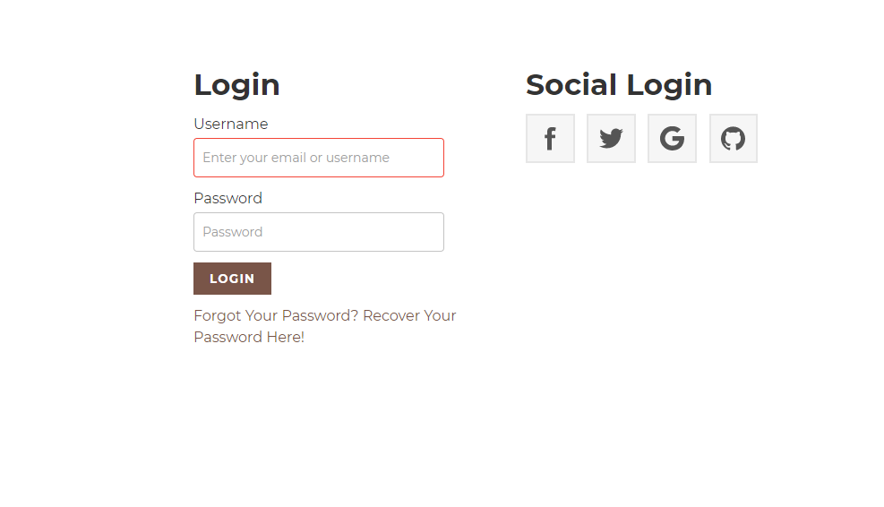

Test Case #43

Test Case Steps:

- User cannot be logged out, because token has no expiration time

1. Open browser and go to: <http://demo.baasic.com/angular/starterkit-photo-gallery/main>
2. Click ‘F12’
3. Go to ‘Network’ - ‘All’
4. Click on ‘Response’
5. Click on ‘Request’

Screenshot:

